Swayambhu Stories: Supporting Photos and Links

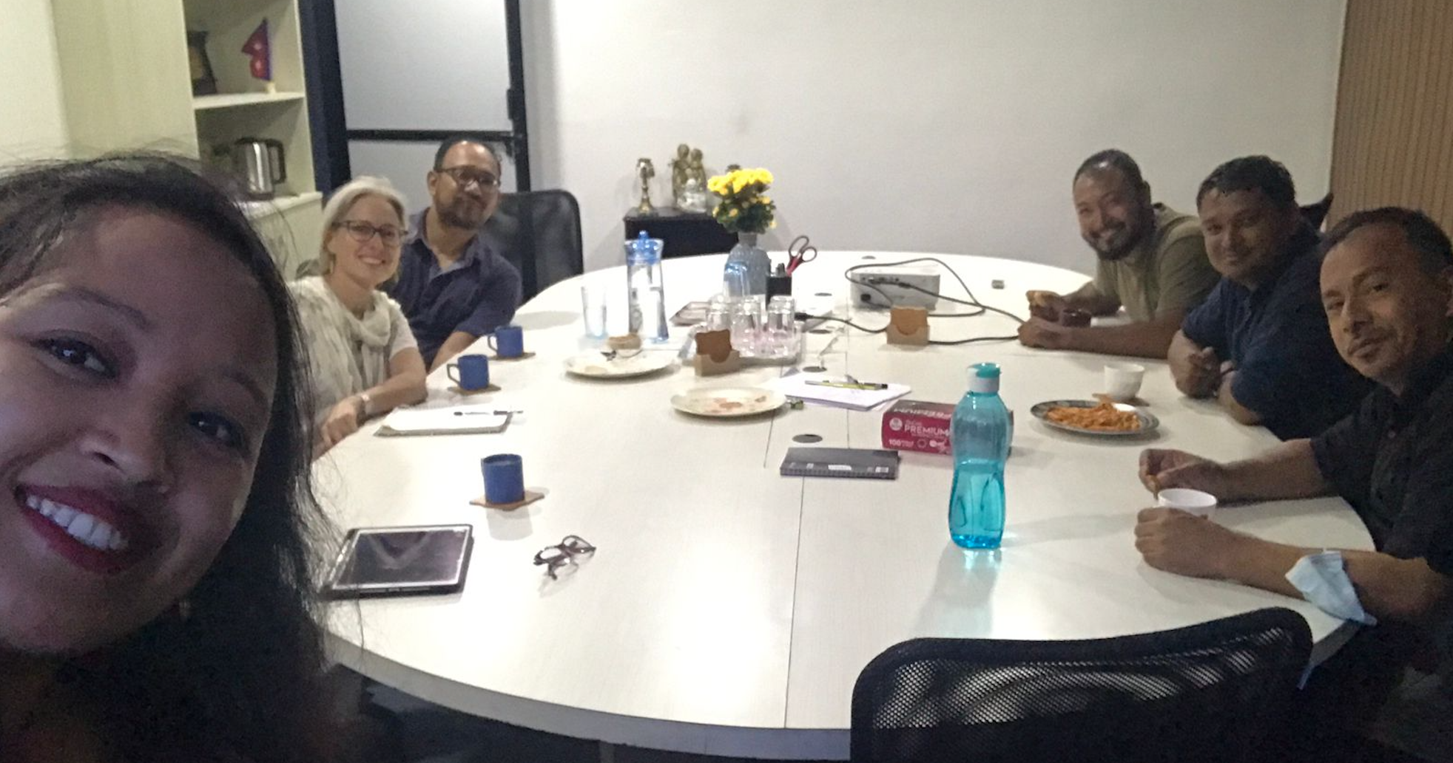
Dr. Leve and the core team in Kathmandu

Helpful links:
- Team site from Comp 528 Fall 2022: https://tarheels.live/teamd/
- Fall 2022 product: http://www.swayambhu-stories.apps.cloudapps.unc.edu/
- Website with simpler, un-annotated 3D models of Himalayan Buddhist monuments and objects that Prof. Leve has produced: https://nepalbuddhism3d.web.unc.edu/
- More information about Swayambhunath: http://swayambhu.buddhism-foundation.org/

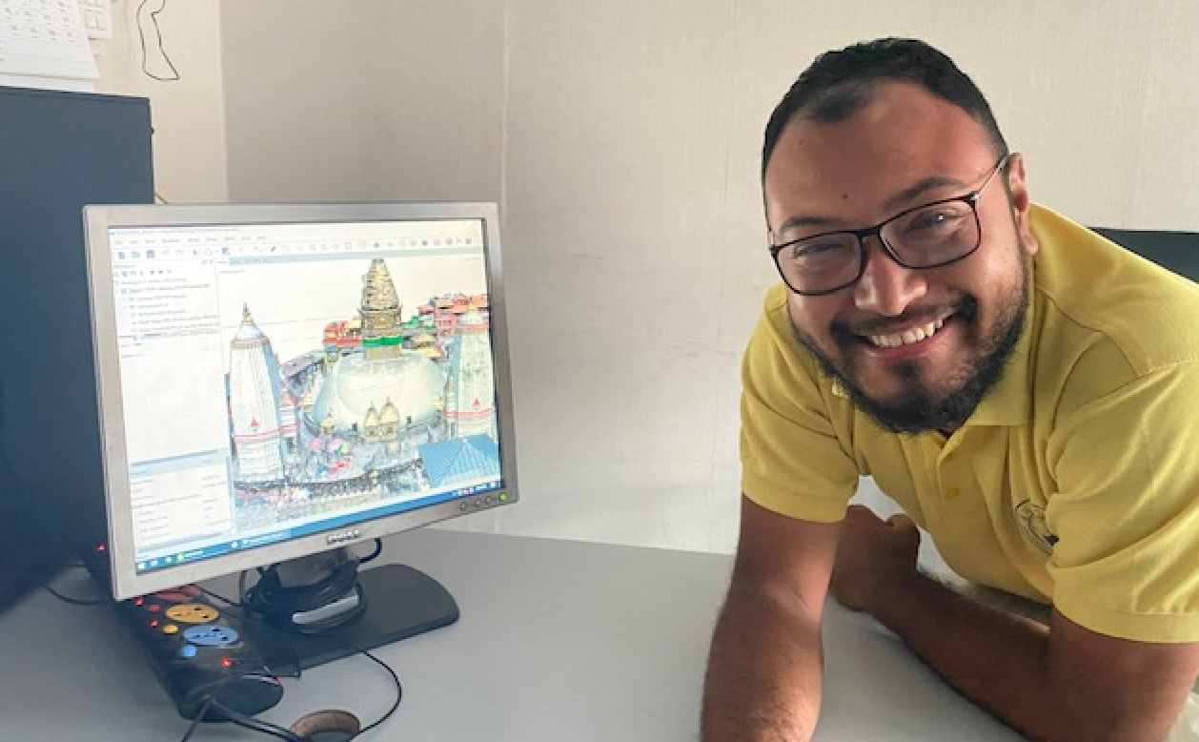
Team member with point cloud
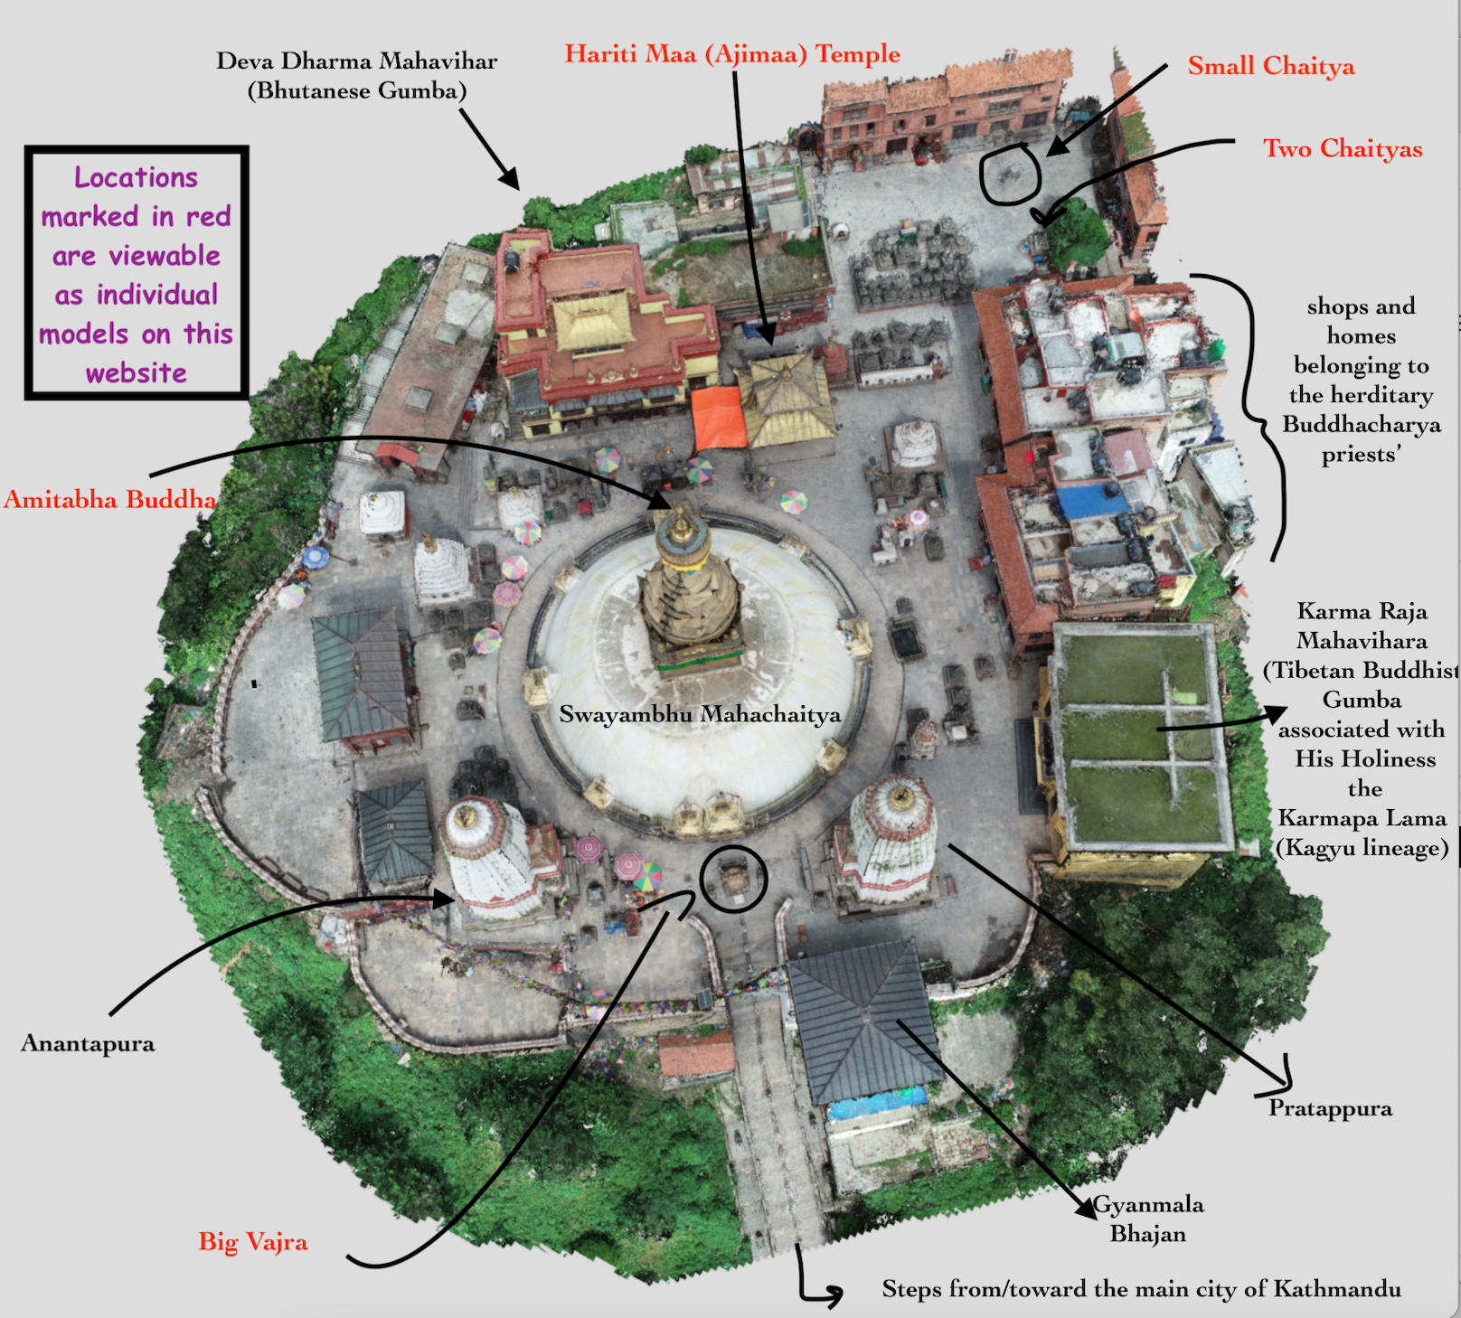
Arial overview of Swayambhu site.

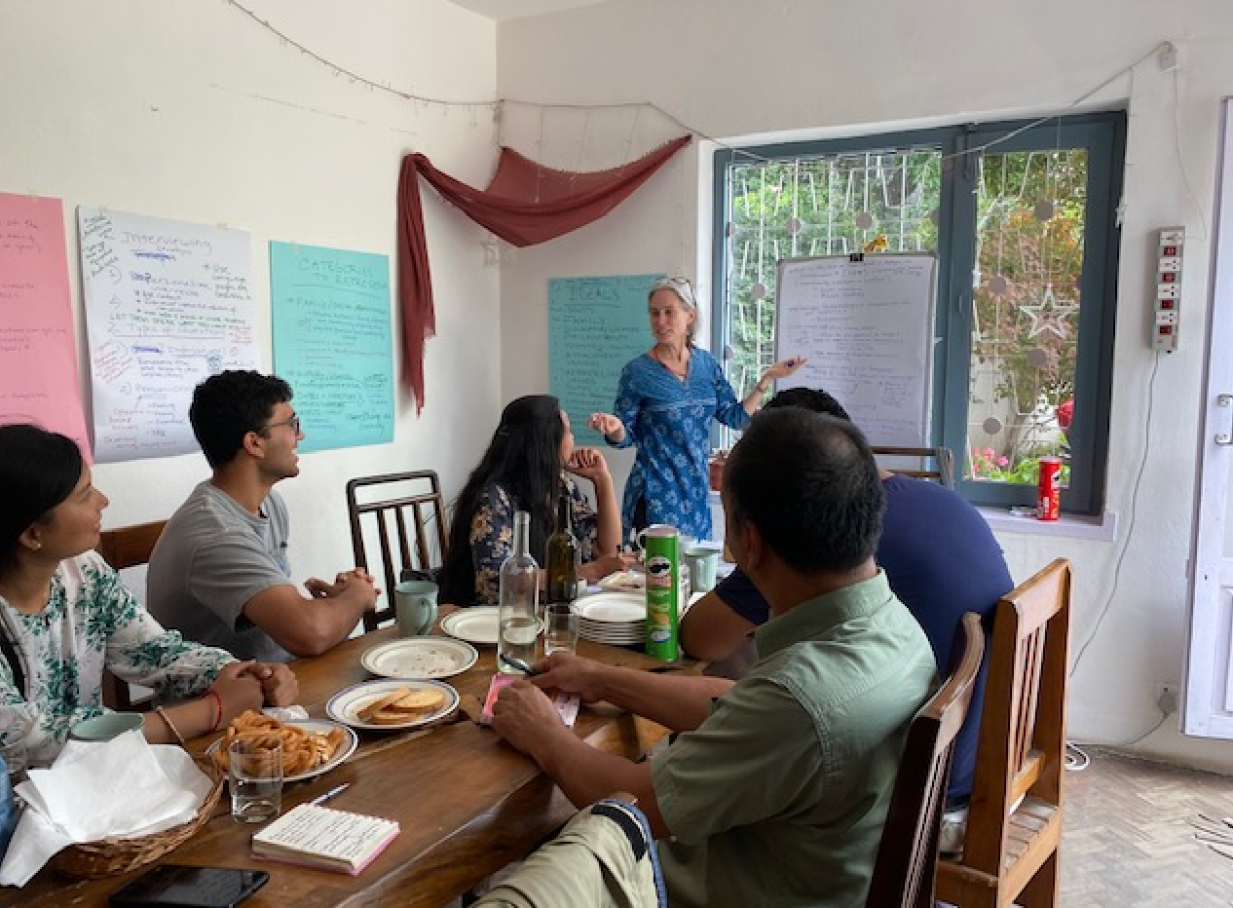
Dr. Leve and the Nepal team deliberating about what kinds of interviews to do and how to decide what parts of video interviews to upload to the model

Interviewing (creating the videos to edit and annotate the model with selected excerpts):

